ABC’s of CULTURES

BACT/AEROBIC CULTURE-SKIN INCL GRAM STAIN (87070, 87205) (RPS LIS Code: AERCU):
- Specimen Type: Culturette swab. (Red Top)
- 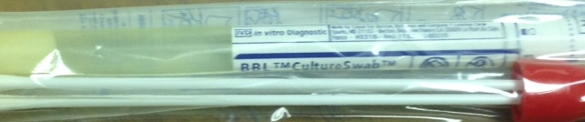
- Transport/Storage: Submit room temperature a.s.a.p. or within 24 hours strongly recommended. Can accept up to 48 hours.
- Notes:
  - Culture will report if yeast is present but will not classify which type of yeast it is. If a mold grows within the 1st 48 hours the microbiology department will call the submitting facility and ask if they want the mold identified. If they do, the submitting facility will order a Fungal ID (87107).
  - Staph, Strep, Yeast (Candida), Pseudomonas, rashes, diaper rashes (NOT FUNGUS)

CULTURE, BACTERIAL, MRSA, NARES (87081) (RPS LIS Code: MRSCU):
- Specimen Type: Culturette swab (Red Top)
- Transport/Storage: Submit room temperature a.s.a.p. or within 24 hours strongly recommended

*CULTURE-TISSUE-BACTERIAL (87070, 87205, 87075, 87175) (RPS LIS Code: TISCU):
- Specimen Type: Tissue in sterile container. Moistened slightly with sterile saline. Moisten if on gauze also. (1mm TISCU only) (5mm (FUNCU, TISCU, AFB)
- Transport/Storage: Submit room temperature a.s.a.p. or within 24 hours strongly recommended. Can accept up to 48 hours.
- Notes: Includes gram stain.

FUNGAL CULTURE – DERMATOPHYTES (87101) (RPS LIS Code: FUNDCU):
- Specimen Type: Skin or nail scraping/shavings or hair in a sterile container. Not ideal, but will accept a Culturette swab.
- Transport/Storage: Submit room temperature a.s.a.p.
- Notes:
  - Most commonly ordered
  - Ringworm, nail fungus, athletes foot, teni, (NOT YEAST)

*FUNGAL CULTURE- Other (87102) (RPS LIS Code: FUNCU):
- Specimen Type: Tissue in sterile container; moistened with sterile saline, pus, purulent fluid, respiratory specimens, body fluid or biopsy. 5 mL fluid minimum
- Transport/Storage: Submit room temperature a.s.a.p.
- Notes: Full fungal culture. Will ID yeast
  - For immune compromised pts.

*CULTURE, AFB &SMEAR (87116, 87206) (RPS LIS Code: AFBCU): (Acid-fast/Atypical bacteria)
- Specimen Type: Tissue, body fluid, drainage, respiratory specimens in sterile container. (1mm AFBCU only), 5mm (FUNCU, TISCU, AFB)
- Transport/Storage: Submit refrigerated a.s.a.p.
- Notes:
  - WILL NOT ACCEPT SWABS OR STOOL or MULTIPLE SAME SITE SPECIMENS (more than one in 24 hours)
  - Sputum and BAL specimen Collection guidelines: 1st sample should be sputum sample from productive deep cough. First morning sample, one sample each morning over three days.
  - AFB Culture may include tissue grinding (LIS Code: TISG) (CPT 87176) and or concentration (LIS Code: MCONC) (CPT 87015).

CULTURE-THROAT RAPID STREP TEST (87880) (RPS LIS Code: ALXSC):
- Specimen Type: Culturette swab. (Red Top)
- Transport/Storage: Submit room temperature a.s.a.p. or within 24 hours strongly recommended. Can accept up to 48 hours.
- Negative samples will be automatically reflexed to culture for backup.

CULTURE, HERPES SIMPLEX VIRUS (HSV) (87252) (RPS LIS Code: VCHSV):
- Specimen Type: Vesicle fluid or lesion on swab from Starswab Multitrans Collection (Viral transport swab-Blue top) and Transport System/swab. Must be submitted in the transport.
- 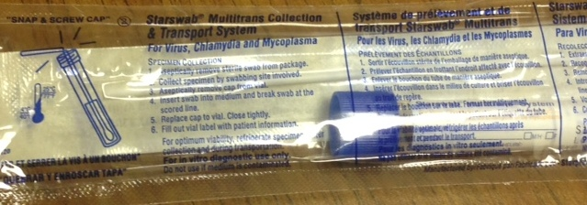
- Transport/Storage: Submit refrigerated a.s.a.p. or within 24 hours strongly recommended. Can accept up to 48 hours.
- Notes: HSV and Varicella can be ordered off one swab

CULTURE, VARICELLA ZOSTER (VZV) (87252) (RPS LIS Code: VCVZV):
- Specimen Type: Vesicle fluid or lesion on swab from Starswab Multitrans Collection (Viral transport swab-Blue top) and Transport System/swab. Must be submitted in the transport.
- Transport/Storage: Submit refrigerated a.s.a.p. or within 24 hours strongly recommended. Can accept up to 48 hours.
- Notes: HSV and Varicella can be ordered off one swab

GENERAL VIRUS CULTURE (87252) (RPS LIS Code: VCGVI):
- Specimen Type: Eye, Stool, Throat swab, Tissue, Lesion swab, Tracheal aspirate, Urine, Blood or Pleural fluid in Starswab Multitrans Collection (Viral transport swab-Blue top) and Transport System.
- Transport/Storage: Submit refrigerated a.s.a.p. or within 24 hours strongly recommended. Can accept up to 48 hours.

Updated 5.2017

